Pre-production work

Project: RTOG

Type: A website with game information.

Main color: yellow(orange) with black(gray)

Main page:

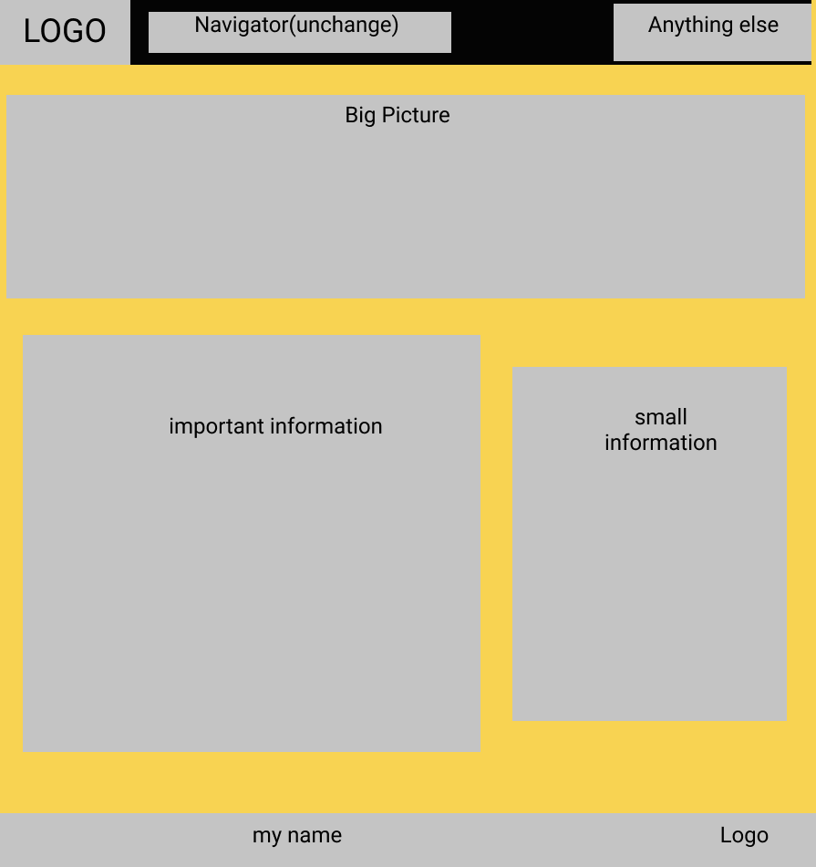

I choose to build a website about Cyberpunk2077.

About us:

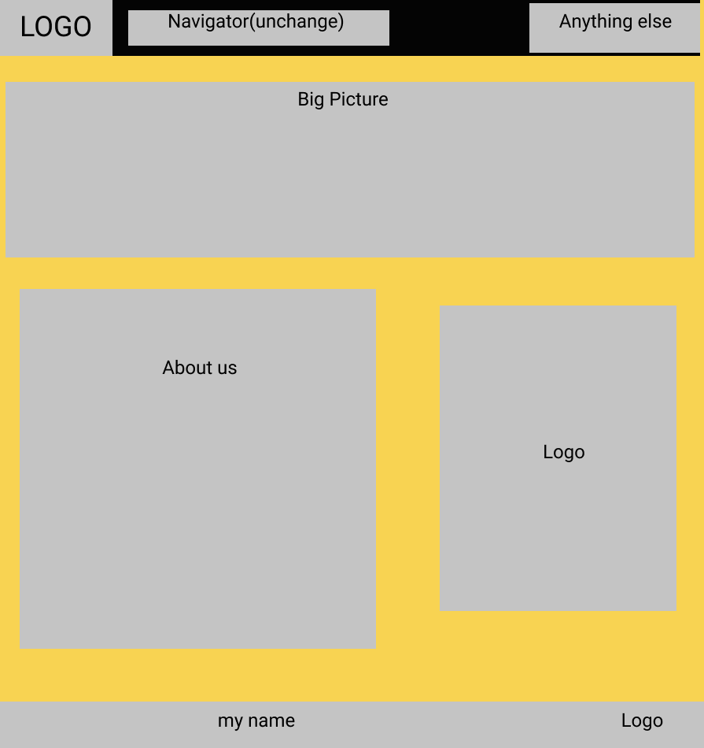

Cyberpunk:

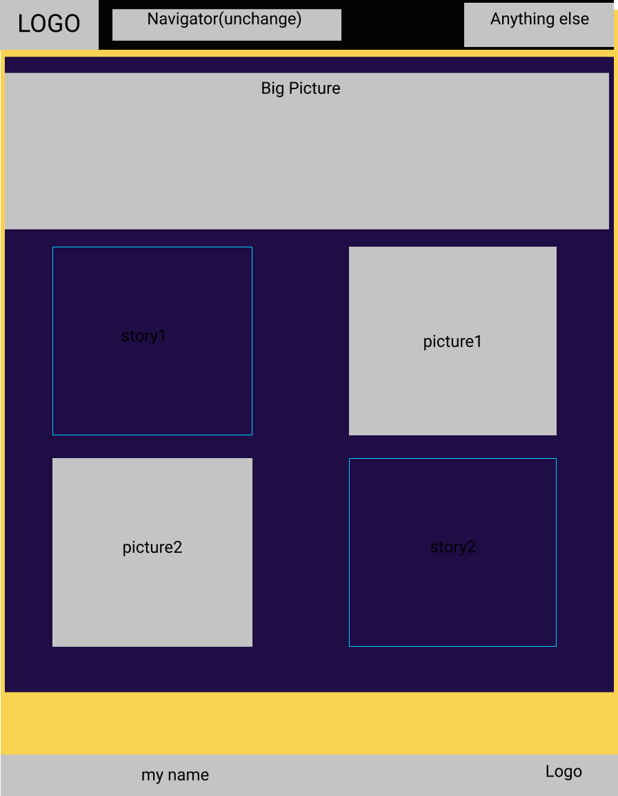

Sample web:

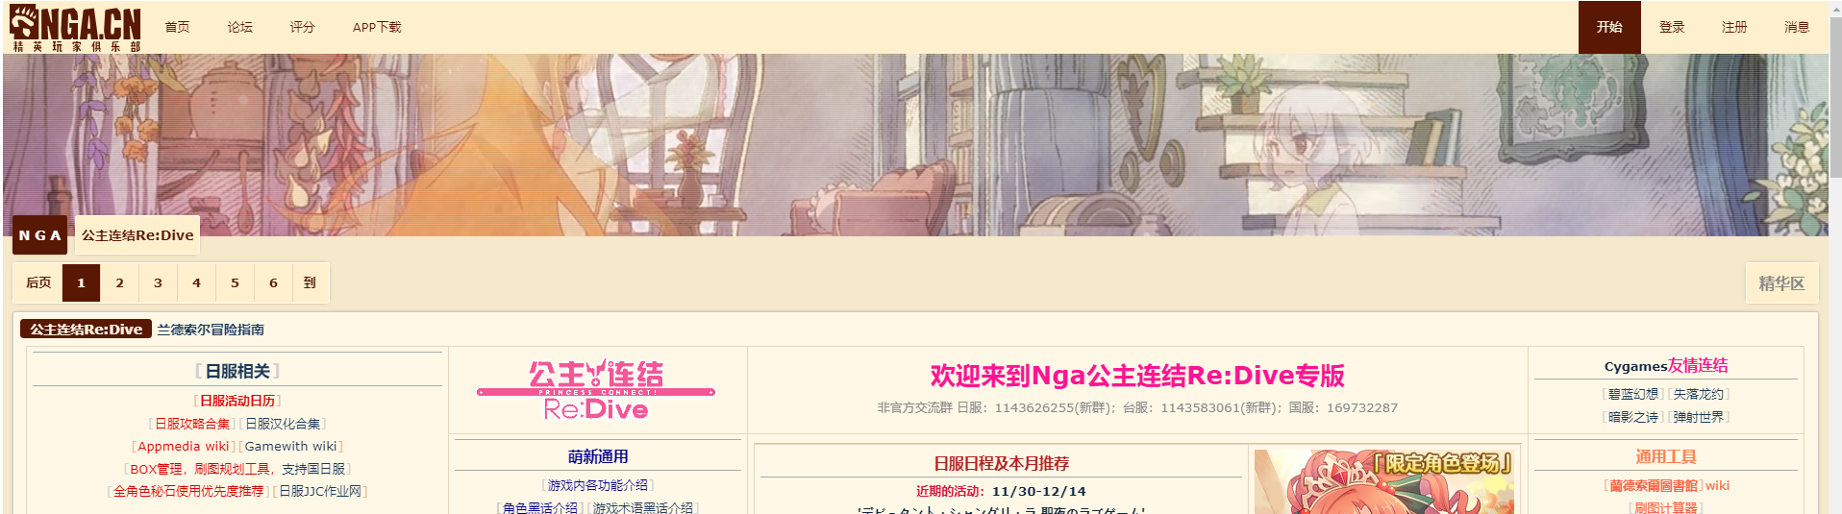

I learn the position of logo and the function of long picture.

NGA

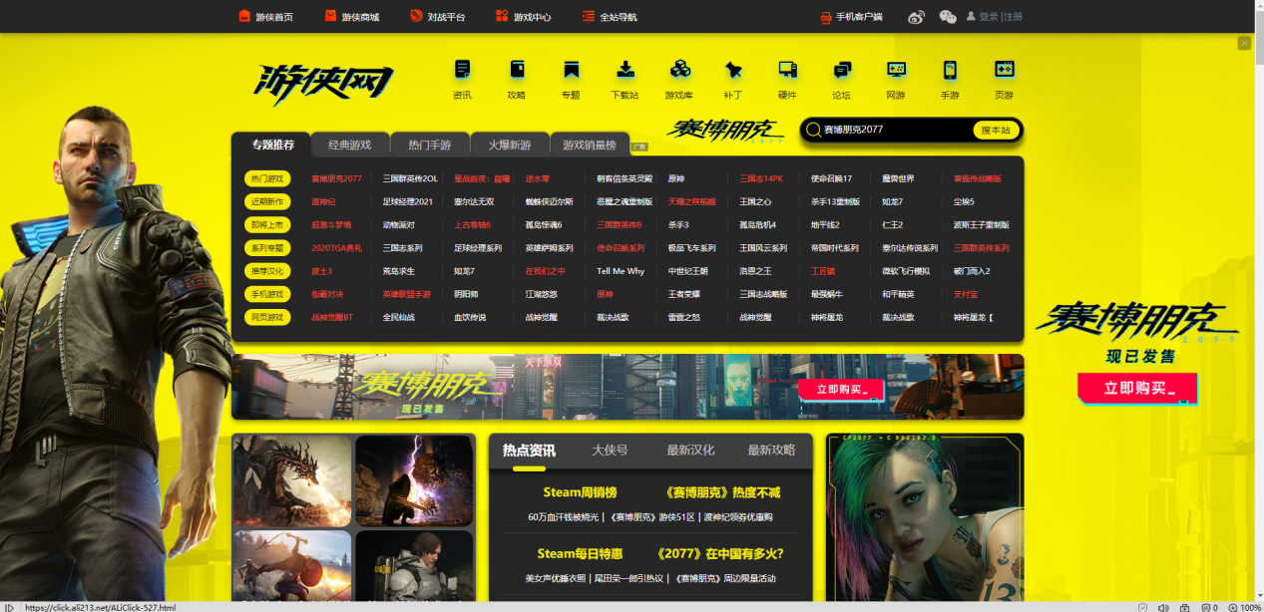

Youxia

I learn the style of its navigation bar.



I chose to put a “log in” and “sign up” button at the right top.

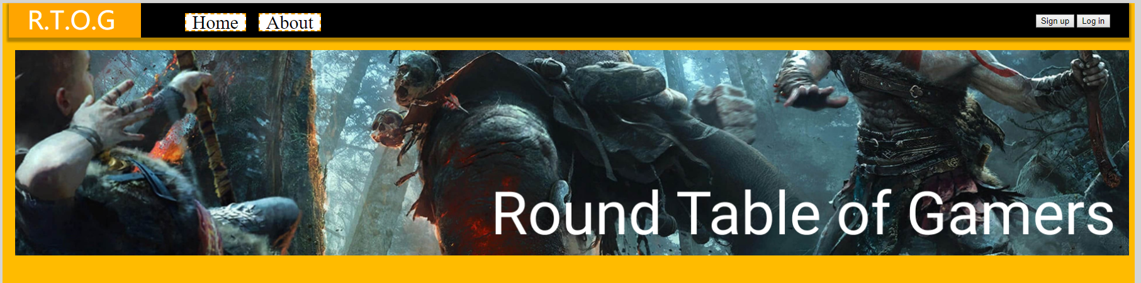

I chose to put a long picture with the fully name of my website. (idea from NGA)

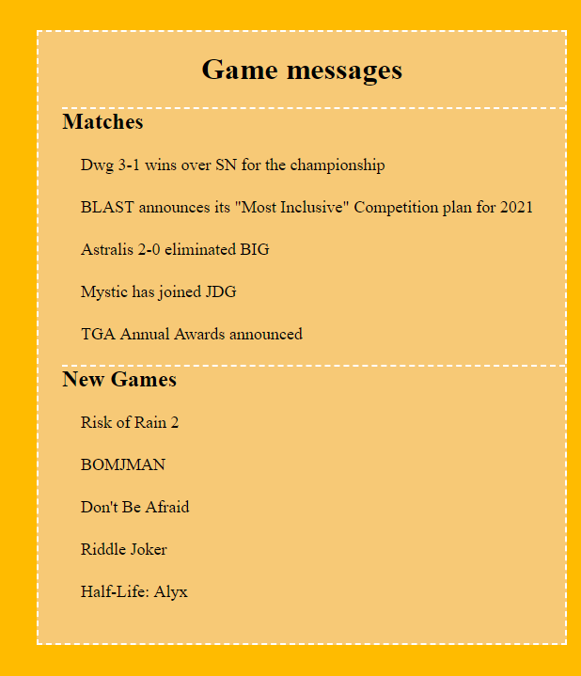

Message list is an very important tool for a game website.